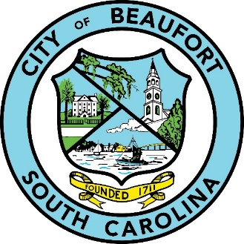
CITY OF BEAUFORT
1911 BOUNDARY STREET
BEAUFORT MUNICIPAL COMPLEX
BEAUFORT, SOUTH CAROLINA 29902
(843) 525-7070

HIGHER EDUCATION TASK FORCE MEETING AGENDA

June 17, 2020

NOTE: IF YOU HAVE SPECIAL NEEDS DUE TO A PHYSICAL CHALLENGE, PLEASE CALL IVETTE BURGESS (843) 525-7070 FOR ADDITIONAL INFORMATION

Electronic Meeting 10:00 a.m.

- Call to Order: Jon Verity & Stephen Murray

- Opening Status of Beaufort Memorial Hospital (BMH), Technical College of the Lowcountry (TCL), University of South Carolina Beaufort (USCB) per COVID-19

- Progress on Expanding Nursing Programs
a. Simulation Lab Collaboration
b. Opportunities on TCL Campus & BMH Buildings
c. Other

- Cybersecurity Initiative Update

- Next Steps and Future Meetings

- Adjournment

